带物联网功能的太阳能控制器使用说明书Solar controller instruction manual with Internet of Things function

—— CMJ系列CMJ series

本系列控制器具备太阳能板直接启动、电池激活功能，并内置物联网模块，可通过互联网远程客户端（比如Web/APP/等）查看和设置控制参数。可用于无人值守电源及应急电源需求的场合。
This series of controllers has direct solar panel activation, battery activation, and built-in IoT module to view and set control parameters via Internet remote clients (such as Web/APP/etc.). Can be used for unattended power and emergency power needs.
特点：Features:
●PV-Power功能：太阳能板直接启动控制器。
PV-Power function：solar panel can start controller directly.
●电池激活，电池维护功能，电池寿命更长久。
battery activation,battery protection,longer battery life.
●电池端0V电压或低压均能启动。
Battery side OV voltage or low voltage can be start.
●具有物联网通讯功能，可通过物联网模块实现控制器远程连接。
With IoT communication function, the controller can be remotely connected through the IoT module.
●采用GSM方式通信，可外置插入2G手机卡，或者物联卡。
Using GSM communication, you can externally insert a 2G mobile phone card or an IoT card.
●支持铅酸、三元锂电池、磷酸铁锂电池。
Support lead acid, ternary lithium battery, lithium iron phosphate battery.
●支持光时控功能。
Support light time control function.
●负载输出：DC 12V/2A，USB 5V/2A。
Load output: DC 12V/2A, USB 5V/2A.
●低电报警、超温报警。
Low power alarm, over temperature alarm.
●电池、太阳能板、负载未接或异常报警。
Battery, solar panel, load is not connected or abnormal alarm.
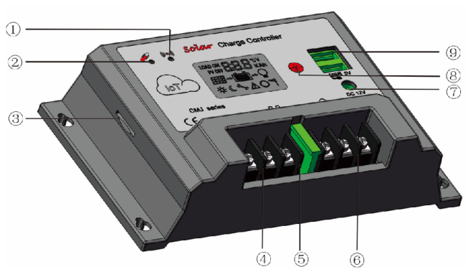
外观：Appearance

序号No. | 名称Name | 序号No. | 名称Name
 | 联网指示灯Networking indicator | ⑥ | 负载接口Load interface
 | 温度传感器Temperature Sensor | ⑦ | DC12V输出接口DC12V output interface
 | SIM卡槽SIM card slot | ⑧ | 开关/设置按键Switch / setting button
 | 光伏阵列接口Photovoltaic array interface | ⑨ | USB 5V输出接口USB 5V output interface
 | 蓄电池接口Battery interface
设置说明及显示 ：Setting instructions and display:
 参数设置、保存与查看按键，在可设置参数的界面长按此键5秒，数字闪动，表示已进入设置模式，设置完毕后，按一下5S保存退出；无操作60秒后不保存退出，返回主界面。（注意：当无操作时，界面将进入自动循环）
Parameter setting, save and view button, press this button for 5 seconds on the interface where parameters can be set, the number flashes, indicating that the setting mode has been entered. After setting, press 5S to save and exit; no operation will not save after 60 seconds. back to main interface. (Note: when there is no operation, the interface will enter the automatic cycle)
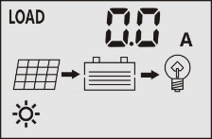
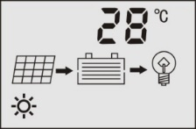
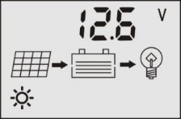

电池电压battery voltage 环境温度environment temp 放电电流discharge current
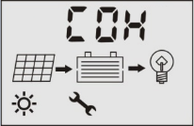
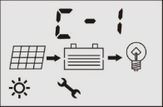

Battery type(can set)电池类型（可设置）load working type(can set)负载工作模式（可设置）

负载工作模式：Load mode
[C0H]手动开关模式（默认开启）。Manual switch mode (on by default).
[L0H]光控模式 Light control mode
[1-12H]光控+延时模式
[P0H]白天启动模式，仅当PV端有电压时启动Daytime start mode, only start when PV terminal has voltage
电池类型 battery type：C-1 铅酸免维护Lead acid is maintenance-free，C-2 胶体colloid，C-3铅酸开口Lead-acid openings
L-3 三元锂电池Ternary lithium battery*3串pcs，L-6 三元锂电池Ternary lithium battery*6串pcs
F-4 磷酸铁锂电池Lithium iron phosphate battery*4串pcs，F-8磷酸铁锂电池Lithium iron phosphate battery*8串pcs
参数：Parameter
型号Model | CMJ-2405 | CMJ-2410 | CMJ-2420 | CMJ-2430
最大充电电流Maximum charging current | 5A | 10A | 20A | 30A
最大放电电流Maximum discharge current | 5A | 10A | 20A | 30A
最大光伏板耐压Maximum photovoltaic panel withstand voltage | ≤55V
USB输出output | 5V 2A
特征feature | 空载损耗no-load loss：≤10mA；温度补偿Temperature compensation：-3mV/cell/℃
工作温度working Temp | -20℃～+60℃
※参数可根据用户要求定制。Parameters can be customized
电池类型battery type  参数Parameters | 额定电压nominal voltage | PV充电截止电压PV charge cut-off voltage | 电池放电截止电压Battery discharge cut-off voltage | 恢复放电电压Recovery discharge voltage
铅酸Lead-acid | 12V/24V | 14.5V/29V | 10.5V/21V | 12V/24V
三元锂电池Ternary lithium battery*3串pcs/6串pcs | 3.7V*3，*6 | 4.2V*3，*6 | 3.0V*3，*6 | 3.7V*3，*6
磷酸铁锂电池Lithium iron phosphate battery*4串pcs/*8串pcs | 3.2V*4，*8 | 3.7V*4，*8 | 2.8V*4，*8 | 3.2V*4，*8
操作说明：operating instructions
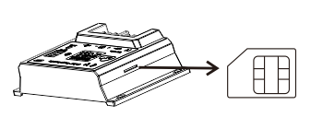
- SIM卡 SIM Card
如图所示，插入SIM卡，10分钟后控制器才可使用，中间需要识别控制器和 寻网的时间。As picture,after inserting the SIM card, the controller can be used after 10 minutes, and the time between the controller and the network search needs to be recognized.
注意Notice：1、该产品不支持热连接。This product doesn’t support hot connections
2、产品测试用的卡为products test cards：中国移动CMCC，上机时请确认SIM卡是否有费用及是否可连网。Pls check the SIM has charger and can contact to internet when using
- 指示灯 Indicator light
寻网时：指示灯边绿色，1S频闪一次Search the network: the indicator light side green, 1S strobe once；
寻网成功时/连接成功：绿色灯亮度变高，闪烁频率加快。When the network is found successfully / the connection is successful: the green light becomes brighter and the blinking frequency is faster.
物联网链接及使用 Internet link and using
方式一 way 1.
以微信小程序为例：such as Wechat app.
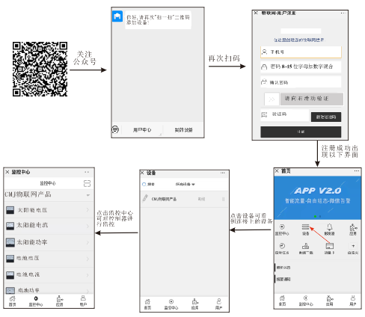

注意Notice：1、扫完码注册后，再上电。Scan code after registration, and then on the electricity
2、二维码以贴在产品上的为准，每个二维码只能绑定一个用户，绑定成功后其他用户扫该二维码无效，如有疑问，可联系厂家。The QR code is subject to the one posted on the product. a QR code with one user. After the binding is successful, the QR code is invalid.
3、由于客户端不断更新，上图仅供参考。On account of clients upgrading usually,the picture only for reference.
方式二 Way 2
云组态网页：Cloud configuration webpage：
1、二维码示例：该二维码无效，已被其他用户使用。（二维码贴于机身表面）QR code example: The QR code is invalid and has been used by other users. (Two-dimensional code attached to the surface of the fuselage)


2、网址示例URL example：http://web.tlink.io/page/73DA0DGTZ60V16152CJ3
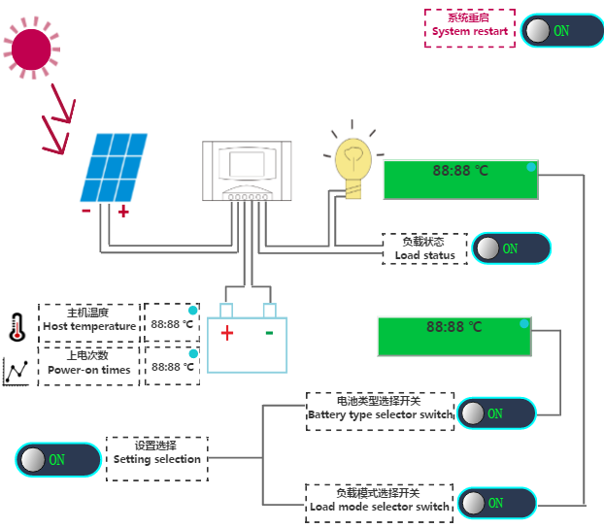
3、展示页面示例Display page example：

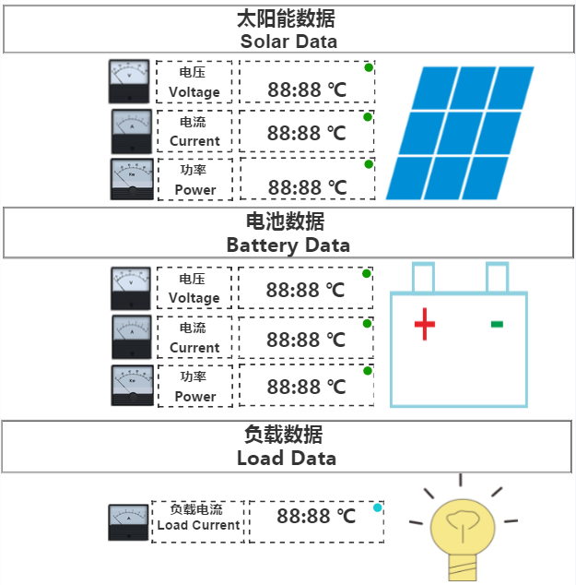

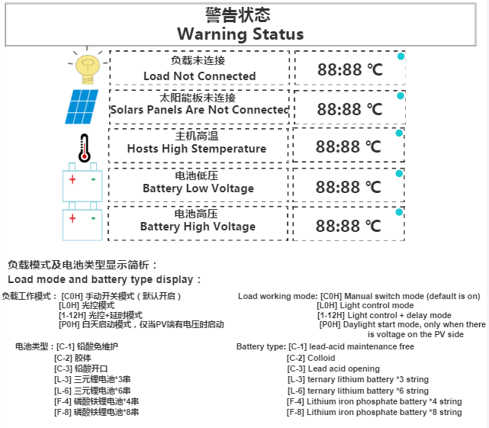
注意：1、每个产品出厂，默认有一个网页网址的二维码，在物联网联网成功的情况下，用户扫描即可查看前端设备的运行状态及对前端进行控制。
- 由于客户端软件不断更新，以上两种方式的描述仅供参考，实际应用，按最新的为准。
Notice：1. Each product leaves the factory with a QR code of the web page URL. When the Internet of Things is successfully connected, the user can scan the operating status of the front-end device and control the front-end.
2.Due to the continuous update of the client software, the descriptions of the above two methods are for reference only, and the actual application is subject to the latest ones.

