CMTD系列太阳能控制器使用说明书
1.产品介绍
CMTD系列液晶屏控制器是一种智能型、多用途太阳能充放电控制器，各控制参数可灵活设定，充分满足您的不同应用需求。
该控制器具有如下特点：
●形象的LCD图形符号 | ●简洁的按键操作
●系统电压自动识别 | ●智能型PWM充电方式
●可调节的充放电控制参数 | ●可设置的负载工作模式
●多电池类型选择 | ●蓄电池过温保护
●蓄电池欠压保护 | ●蓄电池反接保护
●过载、短路保护 | ●双路USB5V输出
2.产品参数
型号 | CMTD-Li310（三串锂电池）  CMTD-A2410（铅酸电池）  CMTD-2410（铅酸电池） | CMTD-Li320（三串锂电池）  CMTD-A2420（铅酸电池）  CMTD-2420（铅酸电池）
最大充电电流 | 10A | 20A
最大放电电流 | 10A | 20A
最大太阳能板输入电压 | ≤50V
额定电压 | 12.6V(3串锂电池)或12V/24V自动适应(铅酸电池)
停充电压 | 12.6V(3串锂电池)；14.7V；29.4V
欠压恢复电压 | 11.1V(3串锂电池)；12.2V；24.4V
欠压保护电压 | 9V(3串锂电池)；10.5V；21.0V
USB输出电压/电流 | 5V 2A
特征 | 空载损耗：≤10mA；温度补偿：-3mV/cell/℃
工作温度 | -20℃～+60℃
*参数可根据用户要求定制。

3.安装说明
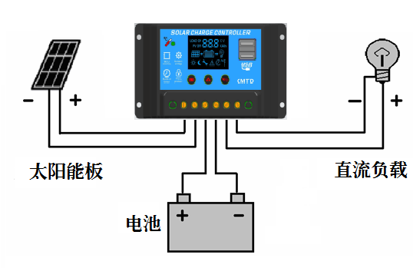
如左图所示，太阳能、蓄电池、负载的接线，请注意连接时，先接蓄电池, 然后接太阳能板和直流负载。

4.设置说明及显示
参数设置、保存与查看按键
设置方法：在可设置参数的界面长按 键5秒，数字闪动，表示已进入设置模式，设置完毕后，按一下保存退出。
无操作20秒则自动退出设置模式并撤销保存，返回主界面。
参数设置的增加按键 参数设置的减小按键（负载开关）

参数显示说明
CMTD-Li3 三串锂电池+电流显示
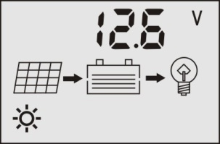 | 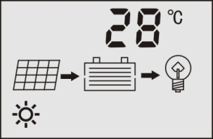 | 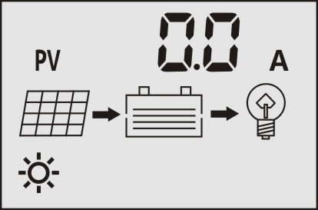 | 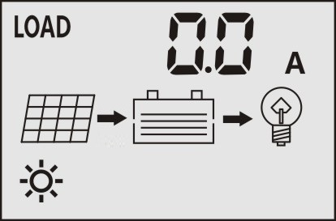 | 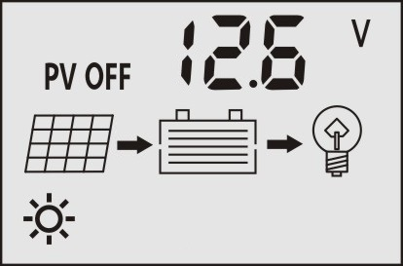 | 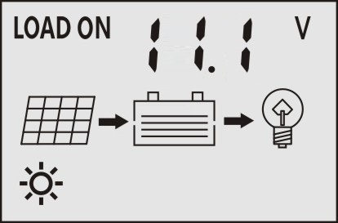 | 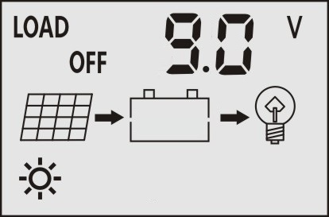 | 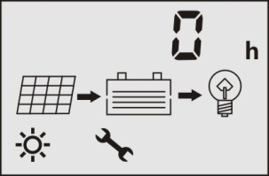 可设
CMTD-A 铅酸电池+电流显示
 |  |  |  | 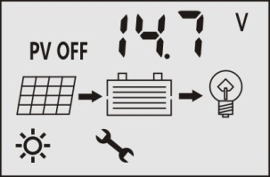可设 | 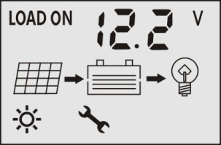可设 | 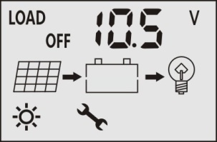可设 | 可设
CMTD 铅酸电池+ 电池类型
 |  |  |  | 可设 | 可设 | 可设 | 可设 | 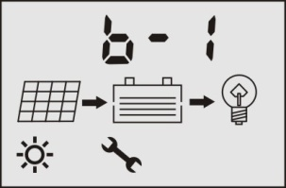可设
蓄电池电压 | 环境温度 | 充电电流 | 放电电流 | 充电截止电压 | 欠压恢复电压 | 欠压保护电压 | 负载工作模式 | 电池类型

负载工作模式（可设） [0h] 手动模式 [1- 23h] 光控延时模式 [24h] 纯光控模式
电池类型 （可设） b-1 密封式铅酸电池 b-2 胶体式铅酸电池 b-3 开口式铅酸电池
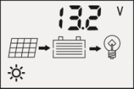
如上图所示，左边“箭头”静止显示表示在直充中，闪烁显示表示浮充充电。无显示，表示未充电。 | 负载开关默认开启，在蓄电池电压查看界面可以使用 键开、关负载。  当按下 键时，LCD界面的右边箭头不显示表示负载已断开，负载停止输出。

注意:当没有阳光时，光强降至启动点，控制器延时6 分钟确认启动信号后，根据设置参数开通负载，负载开始工作；当有阳光时，光强升到启动点，控制器延时6分钟确认关闭信号后关闭输出，负载停止工作。

5.常见故障及处理方法
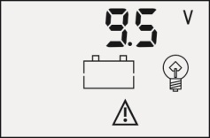 | 欠压报警 | 当蓄电池电压低于欠压保护电压9.0V（三串锂电池）；10.5V（12V系统）；21.0V(24V系统)，控制器已进入欠压保护状态，LCD界面下方会出现图示 ，同时图示  会出现闪烁，负载回路断开防止蓄电池过度放电。此时需使用太阳能电池板对蓄电池充电，当蓄电池电压达到欠压恢复电压11.1V（三串锂电池）；12.2V（12V系统）；24.4V(24V系统)后，控制器将恢复对负载供电。
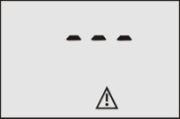 | 输出短路 | 短路过流时，液晶屏如右图所示，尝试恢复10次之后不再尝试恢复，此时需要手动短按 键关闭输出开关，系统才恢复正常工作。

保修单
客户姓名 |  | 联系电话
规格型号 |  | 电子邮箱
产品条码 |  | 购买区域
通讯地址

售后服务：
1.产品售出后如发生性能故障，7天内可退换、维修，____个月内可换或者维修。

2.产品自保修之日起保修 年，超过保修期或不属于免费维修的产品，本公司维修中心仍竭诚为您服务。

3.一切人为损坏、自行拆机、外表损坏、使用不当等，均不在保修的范围内。

特别声明：
本手册的内容如果有更新，恕不另行通知，按照批次或者我司正式发布数据为准。
任何途径购买的产品均可在当地代理商或者我司享受相应的质保服务、技术服务。

CMTD Series Solar Charge Controller
User’s Manual

1. Product Introduction
CMTD series solar charge controller is a kind of intelligent, multi-functional solar charge and discharge controller. All the controlling parameters can be reset flexibly to satisfy your different needs.
This controller has the following features:
● Visual LCD graphic symbol | ● Brief key operation
● Automatic identification system voltage level | ● Intelligent PWM charge mode
● Adjustable charge-discharge control parameters | ●Settable operating modes of loads
● Multiple selection of battery | ● Battery over temperature protection
● Battery low voltage protection | ● Battery reverses polarity protection
● Overload & short circuit protection | ● With Dual USB 5V output

2. Specification
Model | CMTD-Li310（3 series of lithium battery）  CMTD-A2410（lead-acid battery）  CMTD-2410（lead-acid battery） | CMTD-Li320（3 series of lithium battery）  CMTD-A2420（lead-acid battery）  CMTD-2420（lead-acid battery）
Max. charge current | 10A | 20A
Max. discharge current | 10A | 20A
Max. solar panel input voltage | ≤50V
Rated voltage | 12.6V（3 series of lithium battery）; 12V/24V auto work（lead-acid battery）;
Stop charge voltage | 12.6V（3 series of lithium battery）; 14.7V; 29.4V
Low voltage recovery | 11.1V（3 series of lithium battery）; 12.2V; 24.4V
Low voltage protection | 9.0V（3 series of lithium battery）; 10.5V; 21.0V
USB output voltage/current | 5V 2A
Characteristic | No load loss:≤10mA; Temperature compensation:-3mV/cell/℃
Operation temperature | -20℃~+60℃
*Parameters may customized by customers.

3. Installation Instructions
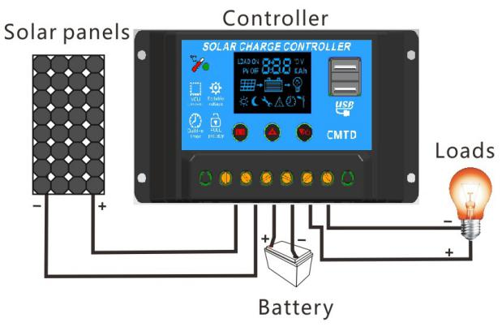
As shown in the installation connection diagram, the battery, solar panel, load and controller should be connected by turns. Please connect the battery first, and then the solar panel or load.

4. Setting Instructions and Parameters Display
Parameters setting and checking button
Setting method:
At the setting interface, keep pressing the button for 5 seconds, the figure flickers, it means the controller enters into the setting mode. After finish setting the parameters, shortly press the button and the controller will save the set parameters automatically.
At this interface, when there is no operation for 20 seconds, it will automatically exit the setting mode, cancel to save the parameters and return to the main interface.
Parameters plus button Parameters minus button（load output switch）

CMTD-Li3 3 series of lithium battery + current display
 |  |  |  |  |  |  | settable
CMTD-A lead-acid battery + current display
 |  |  |  | settable | settable | settable | settable
CMTD lead-acid battery + battery type settable
 |  |  |  | settable | settable | settable | settable | settable
Battery voltage | Ambient temperature | Charge current | Discharge current | Stop charge voltage | Low voltage recovery | Low voltage protection | Load working mode | Battery type
Parameters Display

As shown above, the left arrow static display means it is in direct charge; the left arrow flickers means it is in float charge. If the left arrow without display means it is no charge. | The load output switch default ON. At the battery voltage interface, you can press the  button to turn on or turn off the load.  After pressing the button, the load is disconnected and the load output is stopped.
Load working mode（settable） [0h] Manual mode [1-23h] Light control delayed mode [24h] Light control mode
Battery type （settable） b-1 AGM lead-acid battery b-2 GEL lead-acid battery b-3 OPEN lead-acid battery

NOTE: When there is no sunshine, the light intensity decreases to starting point. Then the controller recognizes the starting signal after six minutes. The load will start to work according to the setting parameter. When there is sunshine, the light intensity rises to starting point, and then the controller recognizes the close signal after six minutes. The load will stop working.

5. Trouble Shooting
 | Low voltage alarm | When the battery voltage lower than 9.0V (3 series of lithium battery); 10.5V (12V system); 21.0V (24system), the controller enter into the state of low voltage protection, the icon appears in the bottom of the LCD and the icon flickers. The load is disconnected in order to prevent it from over discharging. At this time, you need to charge the battery. When the battery voltage return to the low voltage recovery11.1V (3 series of lithium battery); 12.2V (12V system); 24.4V (24system), the load output restart.
 | Short circuit | When short circuit occurs, it shows as the right figure. The controller will not recover after trying to recover for ten times. At this time, you need to shortly press the  button to turn off the load output, and then the system return to normal work.

GUARANTEE
Customer Name |  | Telephone
Model |  | E-mail
Bar Code No. |  | Purchase Area
Address

After-Sales Service
1. After the product has sold, if the function failure occurs, you can choose change or repair it within months.

2. Warranty: years upon the date of purchase. If the product exceeds the warranty period or do not belong to the free repair, our company repair center is still dedicated to serve you.

3. Man-made damage, disassemble the product by yourself, product appearance damage and improper use, all of these may cause the invalidation of product guarantee.

Note:
We keep right to change and update without prior notice.
Any purchase channel of our product may enjoy the appropriate warranty service and technical service in the local agents or in our company.

