ES-100W Inverter/Clamp
manual

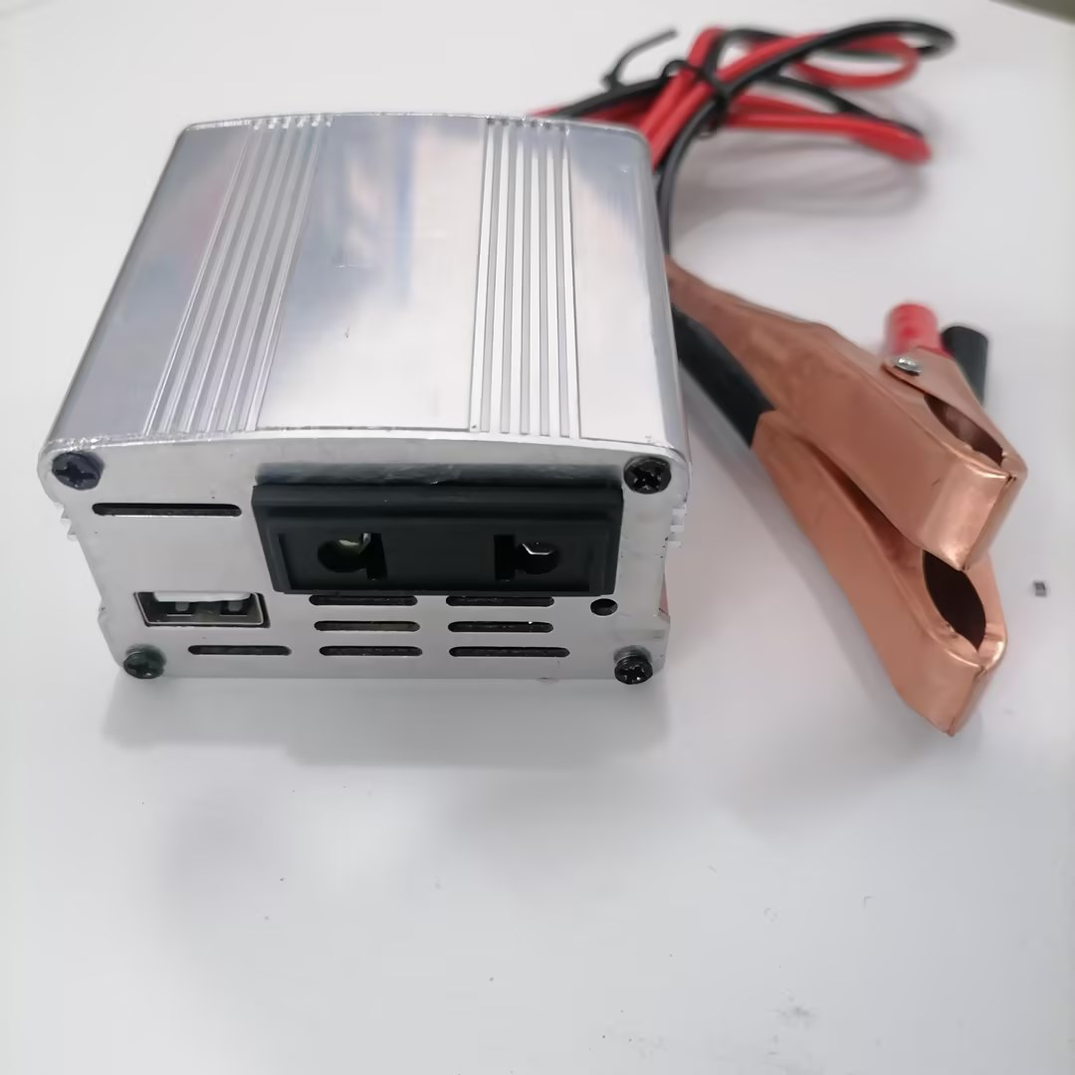

●USB socket charging
●Supporting multiple devices simultaneously

Product Introduction:
■Preface:
Thank you for choosing to purchase and use this product. In order for you to better use all the functions of this product, please carefully read all the precautions and detailed functional operation instructions mentioned in this manual before using this product again
■inventory:
ES-101 in-lion inverter/Clamp * 1, manual/certification* 1
※Due to different production batches, the appearance or accessories of the product may change. Please refer to the actual received product. We apologize for any inconvenience caused.
■Product Introduction:
ES-100W inverter/clamp: The product shell is made of high-quality aluminum alloy, with a fashionable and beautiful appearance. Additionally, in terms of product functionality, the E-100W inverter/clamp has expanded beyond American style sockets, as well as a dedicated USB port.
■Product Technical Features:
1. Mini and compact design, convenient and fast, small size, and space saving
2. Supports USB charging for various devices.
3. Standardized and expanded American style sockets.

■Product Analysis:
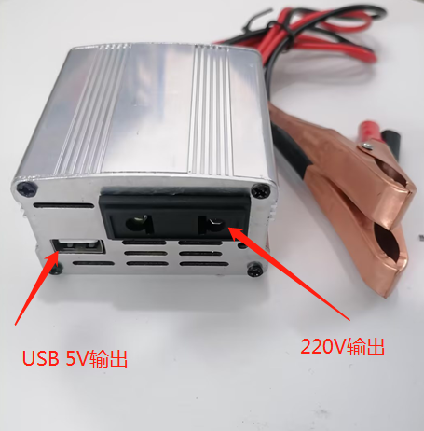
Note: 220V and 110V side panels are optional

Product technical parameters:
[Product Name]: Inline Inverter/Car Charging
[Product Model]: ES-100W
[Product size]: 67*63.5*38MM
[Product Material]: Aluminum alloy
[Input voltage]: 12V
[Output voltage]: 220V/110V
[Product power]: 100W (Max)
[Net weight of product]: About 140G

■Product parameters:
Model | ES-100W
Output power | 100W（MAX）
Inverter output power | ≤100W
12V output power | varies according to input voltage
Input voltage | 12V
Output voltage | 220V/110V
USB PD protocol output | 5V/3A、9V/2A、12V/1.5A
Undervoltage protection | 9V
Overvoltage protection | 16V
Overload protection | 150W
Over temperature protection | 80℃
Output interface | output jack *1
USB interface | USB*1+TPYE*1

Warranty Card
Dear customer:
Thank you for your patronage. From now on, you will receive the after-sales service provided by our company for the products, fully providing guarantees for users in accordance with the national three guarantees policy
Name |  | Tel
Address
Model |  | Purchase Date
Repair instructions：

