ES-101 In-line Inverter/Vehicle Charger
manual

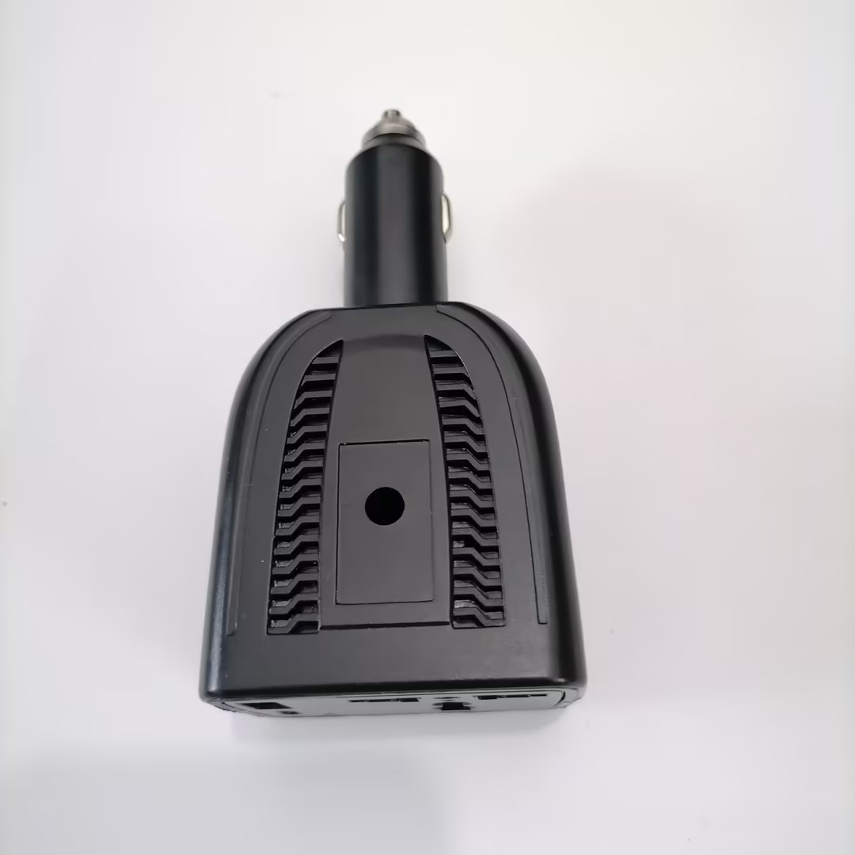

●Multifunctional socket charging
●Supporting multiple devices simultaneously

Product Introduction:
■Preface:
Thank you for choosing to purchase and use this product. In order for you to better use all the functions of this product, please carefully read all the precautions and detailed functional operation instructions mentioned in this manual before using this product again
■inventory:
ES-101 in-lion inverter/vehicle charger * 1, manual/certification* 1
※Due to different production batches, the appearance or accessories of the product may change. Please refer to the actual received product. We apologize for any inconvenience caused.
■Product Introduction:
Direct plug-in inverter/car charger: meticulously developed for expanding the travel companion of your car. The product shell is made of high-quality fireproof PC material, with a fashionable and beautiful appearance. In terms of product functions, the expansion function of the direct plug-in inverter/car charging includes national standard sockets (such as American and Australian standards), as well as a dedicated USB port and TYPE-C interface, which can provide timely power to the phone during driving without worrying about the digital device not finding the charging location.
Product installation:
■Installation Guide:
1. Turn the car key to ACC or ON position and connect to the car power supply.
2. Insert the product directly into the car cigarette lighter and firmly insert it.
3. Kind reminder, when using QC3.0 or PD fast charging, the charging cable should use the original data charging cable to achieve the fast charging function. Ordinary two cables can only support regular charging.
4. Insert the plug of the household appliance product into the power socket of the inverter to enjoy 220V.
■Product Technical Features:
1. Mini and compact design, convenient and fast, small size, and space saving
2. Supports various device charging, fast charging, flash charging (interfaces such as PD/QC3.0)
3. Standard expansion socket (socket national standard, American standard, British standard optional)
■Notes:
1. Please unplug the cigarette lighter plug of this product when starting the car, otherwise it may cause power outage to the electrical product in use and may cause product damage.
2. When using the power supply, please insert it into the car cigarette lighter and wait for 15 seconds before inserting the electrical product. This is beneficial for extending the service life of the car power supply.
3. This product produces a slight noise (such as a fan) when supplying power to electrical products containing electric motors or transformers, which is normal.
4. After long-term use of this product, do not touch the positive contact on the cigarette lighter plug, as the positive contact of the cigarette lighter plug may be very hot after long-term use, and direct contact may burn the skin.
5. When using this product to charge products with tactile screens such as laptops or netbooks, please use a standard data cable with a ground wire for power supply, otherwise static interference may occur and affect the use of electrical products.
6. This product cannot be used for electrical equipment with frequent instantaneous power changes, otherwise it may cause power outage to the electrical product due to product overload protection (such as instant heating soldering iron, fast start high-power fluorescent screen).
7. If using this product for power supply for a long time, please ensure that the power of the household appliance product is below 80% of the rated power of the vehicle power supply, and ensure good ventilation around the product.
8. To prevent excessive battery consumption in your car, we suggest that you start the car engine for 10 to 20 minutes every time you power on for more than 1 hour to replenish the battery power.
9. Before use, please check that the power on the nameplate of this type of product cannot exceed the output power of this product.
10. This product is not suitable for electrical equipment (such as oscilloscopes, induction cooker frequency meters, medical device timers, and life support instruments). This product has high voltage and it is prohibited to disassemble or modify it.
11. To ensure your personal safety, please do not operate this product while driving.

■Product Analysis:
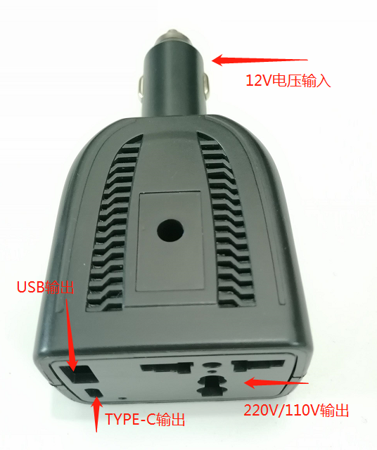
Note: 220V and 110V side panels are optional
Product technical parameters:
[Product Name]: Inline Inverter/Car Charging
[Product Model]: ES-101
[Product size]: 120 * 58 * 44MM
[Product Material]: Fireproof PC
[Input voltage]: 12V
[Output voltage]: 220V/110V
[Product power]: 100W (Max)
[Net weight of product]: About 100G

■Product parameters:
Model | ES-101
Output power | 100W（MAX）
Inverter output power | ≤100W
12V output power | varies according to input voltage
Input voltage | 12V
Output voltage | 220V/110V
USB PD protocol output | 5V/3A、9V/2A、12V/1.5A
TYPE-C protocol outputs | QC2.0、QC3.0、FCP、SCP、AFC、SFCP
Undervoltage protection | 9V
Overvoltage protection | 16V
Overload protection | 150W
Over temperature protection | 90℃
Output interface | output jack *1
USB interface | USB*1+TPYE*1

Warranty Card
Dear customer:
Thank you for your patronage. From now on, you will receive the after-sales service provided by our company for the products, fully providing guarantees for users in accordance with the national three guarantees policy
Name |  | Tel
Address
Model |  | Purchase Date
Repair instructions：

