Es series inverter user manual
一、brief introduction
Thank you for purchasing es series inverter. In order to use this product comfortably and safely, please read this manual carefully. The manual contains important information about this product. Please keep this manual for future reference.
Es series inverter has the excellent quality you expect. Whether you connect it to the jack of automobile cigarette lighter or to the battery, it can be directly converted to AC. It can be widely used in all kinds of household appliances to give you a steady stream of power in business work, driving travel and power failure emergency.
二、Product characteristics
It adopts precise circuit and has perfect protection function and indication function. High quality double-sided circuit board and electronic components are adopted to ensure high quality and high performance of products. The utility model has the advantages of high conversion efficiency, small size, light weight and wide application range.
Product diagram：

model | ES-303-110V | ES-303-110V | ES-303-220V | ES-303-220V
picture | 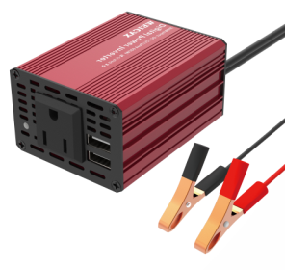 | 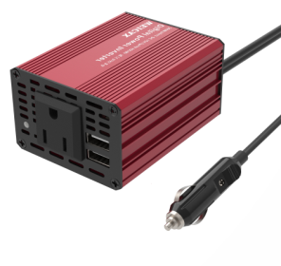 | 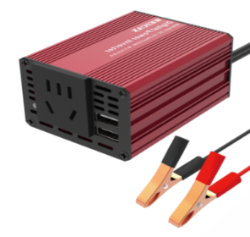 | 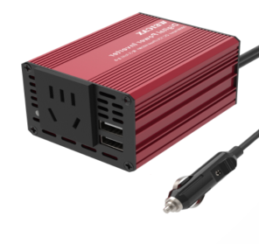
model | ES-603-110V | ES-603-110V | ES-603-220V | ES-603-220V
picture | 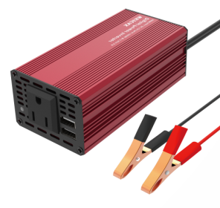 | 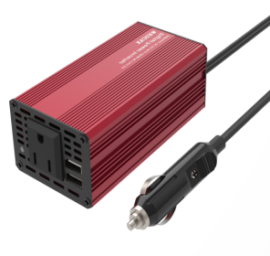 | 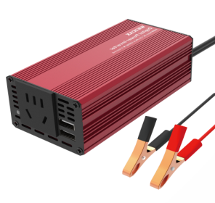 | 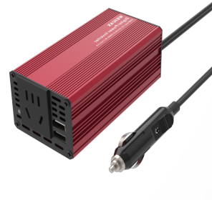
三、instructions
a：Use environment
Based on safety and performance considerations, ES series products should be used in the following environments：
dry： Do not soak in water or rain
shade：The ambient temperature should be between 0 ℃ and 40 ℃
improve air circulation：
Keep 5cm above the shell free of foreign matters and other end faces well ventilated. Confirm that the fan will not be blocked or obstructed during operation (applicable to products with fans), so as to prevent poor ventilation。
b：Operation method
1、Determine that the electrical power used shall be less than the rated output power of the inverter used.
2、When the output power of the equipment is less than 300W, place the inverter switch in the off position, and then insert the cigar head tightly into the socket of the cigar lighter in the vehicle to ensure good contact between the cigar heads.
3、If the crocodile clip is used to connect the battery, the red crocodile clip is "+" and the black crocodile clip is "－".
4、After the input terminal is connected, turn on the switch, the fan rotates, and the inverter indicator will light up, indicating that there is AC output, and the inverter can start to work normally.
5、Plug the electrical appliances to be used into the AC socket or USB interface at the output end of the inverter for charging, depending on the equipment you use。
6、Turn on your electrical switch and the ES inverter can bring you a steady tream of AC energy.
四、Product specification
parameter | EG-500
Rated input voltage | 12VDC
Rated power | 500W
Maximum peak power | 1000W
output voltage | 110V | 220V
output frequency | 60HZ | 50HZ
Output waveform | Sine wave
Overvoltage protection voltage | 15V
Undervoltage protection voltage | 9.7V
Undervoltage recovery voltage | 10.4V
Functional protection | Automatic recovery of low voltage, overload, overvoltage, high temperature and output protection
Output efficiency | 85%-90%
Net weight | 2KG
Product size | 252*215*89
五、Protection function
This series of inverters have multiple protection functions, which can bring you more protection (if the power exceeds 160W, it is recommended to use the direct connection battery with clip)
·Low voltage protection
When the input voltage of the inverter is lower than 10.3v, the inverter will shut down automatically。
·Overvoltage protection
When the input voltage of the inverter is greater than 15.7v, the inverter will shut down automatically.
·overload protection
When the starting power of the load equipment is too large, the inverter will shut down automatically.
·Over temperature protection
When the internal temperature of the inverter exceeds the safe temperature due to the increase of ambient temperature, the inverter will shut down automatically.
·Short circuit protection
When the inverter is short circuited or the connected equipment is short circuited, the inverter will shut down automatically.
六、matters needing attention
1、Children are prohibited from using this product.
2、Do not insert any object or try to pry open the inverter. There may be a risk of electric shock and damage to the inverter.
3、The voltage generated by the inverter is the same as that of the household socket. Do not use it illegally to avoid danger.
4、Do not use the inverter in a humid, flammable gas and closed environment above 40 ℃ or below 0 ℃ to avoid accidents.
5、When plugging the equipment plug from the inverter AC socket, please pay attention to avoid electric shock.
6、Do not overload use, and ensure that the power of the electrical appliance does not exceed the rated power of the inverter purchased.
7、The nominal voltage of the battery must be consistent with the input voltage required by the inverter, and the voltage used by the electrical appliance must be consistent with the nominal output voltage of the inverter.
8、The cigarette lighter plug lead or attached crocodile clip of the inverter must distinguish the polarity. The red line is "+" and the black line is "-", otherwise it is easy to burn the inverter.
9、If the vehicle power supply is used, it is recommended that you make your vehicle engine work for 10 to 20 minutes after using the inverter for a period of time, so as to ensure that the battery power will not be too low. The inverter can work at the same time after the engine is started, but undervoltage shutdown may occur due to excessive voltage drop at the moment of starting the engine, which can be recovered after the vehicle is started.
10、If your car battery voltage is 24V, please do not use 12V input inverter.
11、When using inverter power supply, the greater the power of the appliance, the shorter the service time of the battery, and the larger the capacity of the battery.
12、After the inverter is used continuously, the surface temperature of the shell will rise. Please note that the air flow is unobstructed and the objects vulnerable to high temperature should be kept away.
13、Please do not touch the tip of the cigarette lighter plug after use, because the tip of the plug may be very hot and may cause slight burns to your skin.
14、The output of this series of inverters is corrected sine wave, and some electrical appliances are not suitable for use; Such as medical machines, timers, measuring instruments, induction cooker and other machines that need pure sine wave and precision power frequency.
15、The AC output socket of the inverter can only supply power and cannot be connected in parallel with the mains power, otherwise the inverter will be damaged.
七、Problem solving
Ⅰ) If the inverter cannot be started, please check whether the following items are normal.
1、When the automobile cigarette lighter is used as the input power supply, whether the cigar head of the inverter is inserted in place and loose. Confirm that the power supply of automobile cigarette lighter is normal.
2、Whether the inverter switch is on.
3、When connecting the battery with an alligator clip, check whether the lead connection is normal and whether the power supply battery can work normally.
Ⅱ) Inverter warning light flashes
1、Inverter warning light flashes
2、Check whether the load is short circuited.
八、Warranty description
Warranty period: if this series of products break down under normal operation and use and are not disassembled and repaired without permission, they will enjoy warranty service within one year from the date of purchase.
The following situations are not covered by the warranty, and a little maintenance fee will be charged as appropriate:
1、Product packaging and appearance；
2、Machine damage caused by improper user operation or improper transportation；
3、Replace, dismantle and repair the machine by yourself or not repaired by the company；
4、Machine damage caused by lightning, flood, fire and other natural disasters;
5、Beyond the warranty period；
6、The user connects the product to the equipment that does not meet the specifications, causing damage to the machine.

