GA Series LED Grow Lights
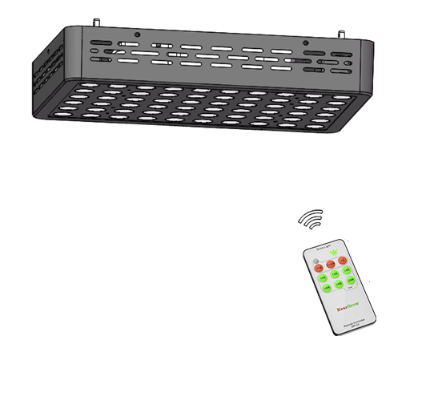

Intelligent Control System Manual

SMART REMOTE CONTROLLER MP-23
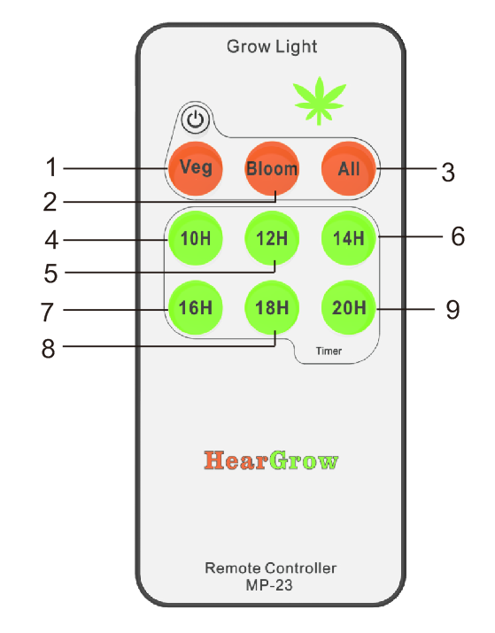
More power, More performance, More pro.
- Remote control
- Automatic circulation timing function
- Temperature and humidity detection function
- Group control function
Button on MP-23smart remote controller
- Veg Button
Set the light to VEG mode
- Bloom Button
Set the light to BLOOM mode
- All Button
In default status, one remote controller can only control one light. If you want a remote controller to control multiple lights,please use this feature. Details are described later.
- 10/14Button
Fast timing button 10ON 14OFF,turn off the light for 14 hours after the lamp has beenlighting for 10 hours from the moment of timing; then automatically turn on for 14 hours and then close for 14 hours, cycle every day.
- 12/12 Button
Fast timing button 12ON 12OFF,turn off the light for 12 hours after the lamp has been lighting for 12 hours from the moment of timing; then automatically turn on for 12 hours and then close for 12 hours, cycle every day.
- 14/10 Button
Fast timing button 14ON 10OFF,turn off the light for 10 hours after the lamp has been lighting for 14 hours from the moment of timing; then automatically turn on for 14 hours and then close for 10 hours, cycle every day.
- 16/8 Button
Fast timing button 16ON 8OFF,turn off the light for 8 hours after the lamp has beenlighting for 16 hours from the moment of timing; then automatically turn on for 16 hours and then close for 8 hours, cycle every day.
- 18/6 Button
Fast timing button 18ON 6OFF,turn off the light for 6 hours after the lamp has beenlighting for 18 hours from the moment of timing; then automatically turn on for 18 hours and then close for 6 hours, cycle every day.
- 20/4 Button
Fast timing button 20ON 4OFF,turn off the light for 4 hours after the lamp has beenlighting for 20 hours from the moment of timing; then automatically turn on for 20 hours and then close for 4 hours, cycle every day.
Reminder: The remote control is not equipped with a battery, pleaseprepare your own.
ALL
(1) Factory Setting:
1.Please wait for 3 seconds after switching on the light on the power line to ensure the normal operation of the remote control.
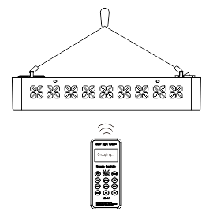
2. One remote controller can only control one light in default status.
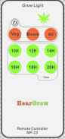
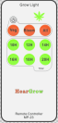
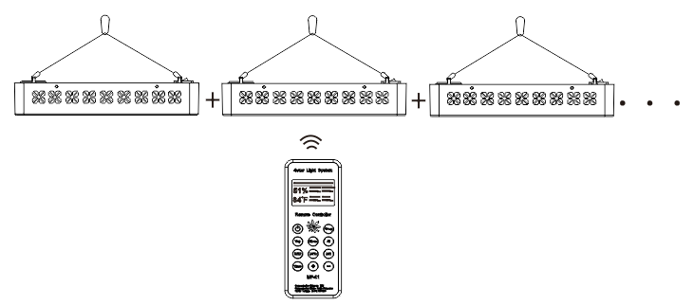
(2) Setting method for controlling multiple lights by only one remote controller.

A remote controller could control multiple lights. And you can add any one light to the control range of the remote controller at any time. The steps are just as follows:
1. Press the “Group” button, and “Grouping” will appear on the screen to start pairing.
2. Turn on the light switch.When you see the flashing of the grow light , that is, the pairing is successful.
(Note: If the light is on, please turn it off and turn on again to complete the pairing)
3. Press the “Group” button again to return to the main screen.
(3) Use occasion:
Users can use multiple remote controllers for group control according to their own growth needs.
(Note: The lights that have been grouped cannot be controlled by other remote controllers. If any one of the lights in the group needs to be separated from the original group to other groups, you just need to repair this light to another controller.)
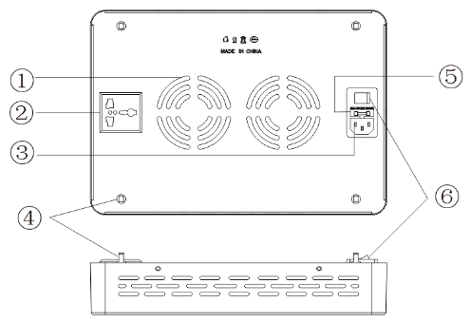
LIGHT OVERVIEW
- Cooling fan
- Daisy Chain Outlet
- Power Cord Inlet
- Brass Hanging Anchor
- Fuse
- Power Switch

QUICK SET UP
- The included hanging hardware is easy to install and requires no tools. Simply attach the clips on the ends of the wire hangers to each of the four gold hanging anchors on top of the light.
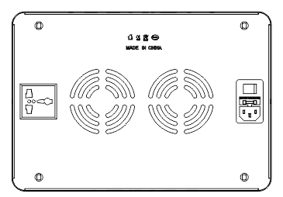
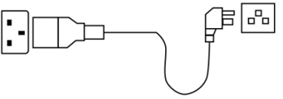
- IMPORTANT: Insert the power cord into the top of your product first and then into a properly grounded power receptacle. Please make sure that all power requirements are considered if running multiple lights on one circuit. (Consult an electrician if you are unsure)
- Your light is now ready to be turned on via the black switch on the side of the light.
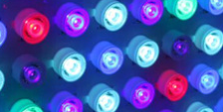
- There are certain diodes that emit infrared light, The IR diodes appear to be off. Do not be alarmed as these diodes are on, working properly, and doing their job.
IR
- Your light should be positioned above the plant canopy at a distance that creates your ideal coverage area. The further away from the canopy the light is positioned the bigger the Coverage area. However, this will also lessen the light’s intensity.

Initially the light needs to be 48” above the canopy for a 3-7-day acclimation period. After this the recommended height is 30”-36” above the canopy. While all plants are different, we suggest keeping minimum distance of 24” between light and canopy.
HANGIMG HEIGHT AND ILLUMINANCE
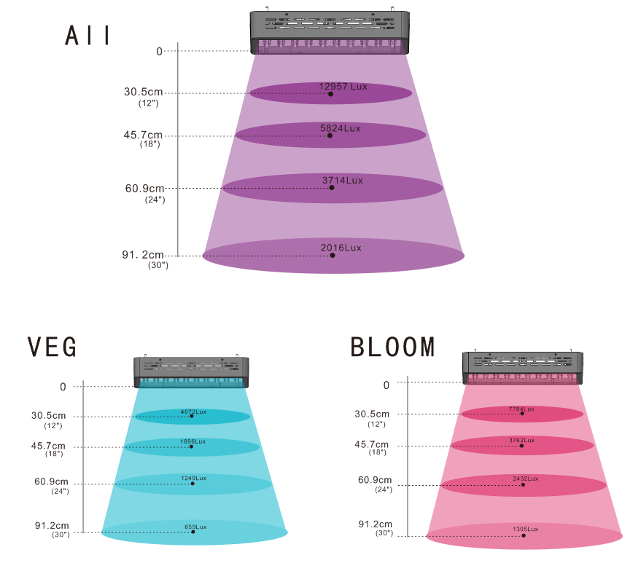
Remote Control Series GA-1800
Remote Control Series GA-2700
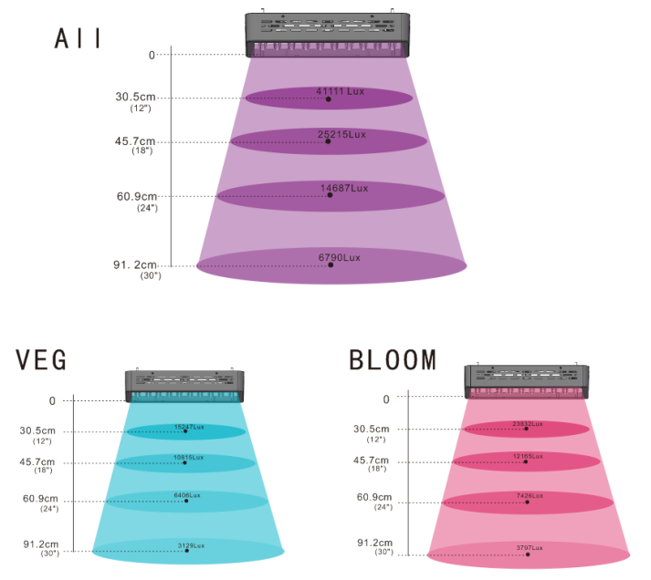
SPECTRUM
ALL ON：
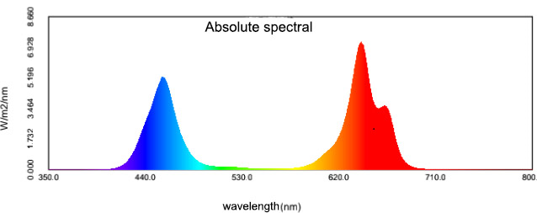

VEG:

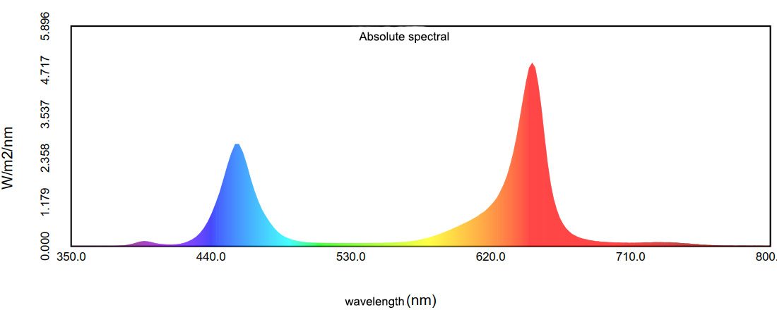

BLOOM:
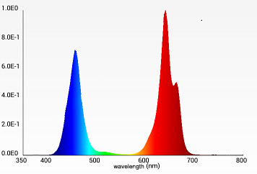
SPECTRUM TUNING
This section will help you to evaluate which spectrum will be best suited for each stage of plants growth.
- Seedlings–Due to the tender nature of seedlings, you will want to tune your light down quite a bit for this stage of life. Once a seed has broken the surface, we recommend a break-in period of about a week where the light will be hanging the height of 48 inches.
Once the seeding has been above ground for about a week, the first set of true leaves should be present. At this point the intensity of the spectrum can be marginally increased. We suggest the light hanging height of 36-48 inches. Once your plant has two or more true sets of leaves, you can set your light to the Vegetative spectrum below.
- Clones – Clones are a little bit harder than fresh seedlings, but still need to be given gentle light as they are completely root-less when first cut, and need to conserve energy and moisture to transition into a rooting stage, we have had great success with rooting clones at the light hanging height of 36 inches.
- Vegetative – In this stage, the deeper red spectrums are utilized less by the plant than when it is in flower and uses high levels of blue light that are essential for creating lush, thick plants that have tight intermodal spacing and very little stretching. This is the same spectrum that will be used for plants that you don’t want to flower, such as leafy greens, basil, and mirco.
- Flowering – At this stage, the plant has a lot of work to do and is preforming many complex biological processes in producing flowers and/or fruits. Because of this, the plant now requires large amounts of light in all categories. For high use plants, we like to set the light to All on mode. For lower light use plants, dialing back all spectrums equally can achieve the proper amount of light while maintaining proper spectrum.
- Late Flower – In this stage most rapid development has stopped and the plant is gearing up for the stage in which the large flowers and fruits will mature or ripen. During this stage, the light can turn on bloom mode and hanging height of 30”-36” in order to mimic those late days of summer and conserve a little extra power in the process.
SPECIFICATIONS
Model | GA-1800 | GA-2700
Input Voltage（AC） | 85~265V
Power | 114W | 177W
Replacement | 68W HPS | 123W HPS
Average Power Draw | 57W | 88W
Frequency | 50/60HZ | 50/60HZ
Number of LEDs | 60pcs | 90pcs
Core Coverage Area at 24"Height | 3.4’x3.8’ | 4.5’x8.0’
PAR Value at 18" height | 595μmol/㎡.s | 760μmol/㎡.s
Lumens | 11823.3lm | 23454.6lm
Working Temperature | -4~+104℉ (-20~+40℃)
Lifespan | ≥50000h
Product Dimensions | 298*206*62mm | 383.6*260.8*62mm
Net Weight | 2.5kg | 3.5kg

Customer Name |  | Telephone
Model |  | E-mail
Bar Code No |  | Purchase Area
Address
After-Sales Service
1. After the product has sold, if the function failure occurs, you can choose
change or repair it within 3 months.
2.Warranty: 3 years upon the date of purchase. If the product exceeds the
warranty period or do not belong to the free repair center is still dedicated
to serve you.
3.Man-made damage, disassemble the product by yourself, product
appearance damage and improper use, all of these may cause the
invalidation of product guarantee.

